SIMATS ENGINEERING
ASSESSMENT TOOL 2

COURSE NAME: Cryptography and Network Security
COURSE CODE: CSA51

COURSE OUTCOME COVERED

CO1: Apply classical encryption techniques using symmetric and asymmetric ciphers to encrypt and decrypt data for the ensuring data security. (BL3, BL4)

Assessment Tool Weightage: 20%

QUESTIONS: 1 Total Marks:50

Annexure A

CONCEPT MAPPING

Code of Conduct:

I ____K Phani Sridhar Yogi 192311091________________ (Name / Reg No) certify that this submission is my original work and that I have adhered to the guidelines specified for this assessment.
I understand that any violation of academic integrity rules will result in disciplinary action.
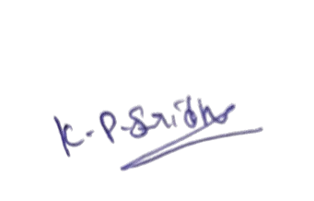

Signature of the student:

